The raspberry pi-based obstacle avoiding robot consists of three main modules i.e., camera module, raspberry pi, motor drivers. The camera module gets the input image which are obtained during real time operation. The raspberry pi is a platform consisting of all necessary hardware module assembled on it. It receives the images from the camera module. It carries out image processing and checks whether there are any obstacles in path of the robot and if any obstacle occurs then it will send the signal further to motor driver accordingly. The motor driver actually of two sub motors- left and right motor. These motors receive the signal from raspberry pi in case of any appearance if the obstacle in its path the motors work accordingly to signal and moves in left or right direction with the help of the left and right motor to avoid obstacles.

WHEELS, CHASSIS & MOTORS

MOTOR DRIVERS

RASPBERRY PI

PI CAMERA

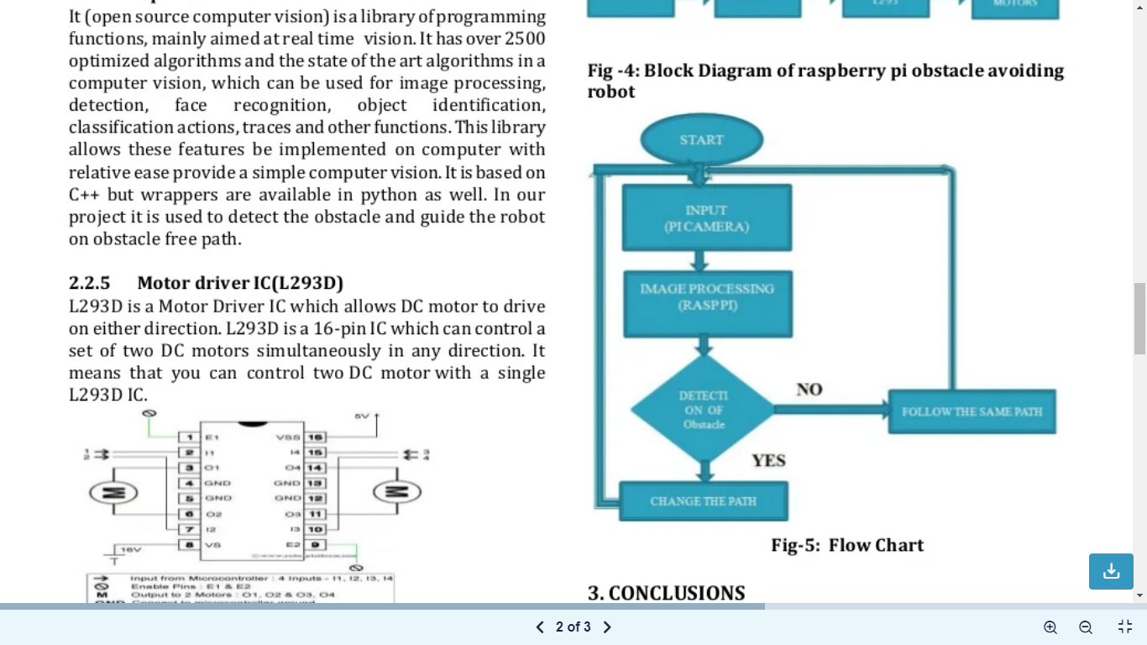

There are two versions of the Camera Module:

* [The standard version](https://www.raspberrypi.org/products/camera-module-v2/), which is designed to take pictures in normal light
* [The NoIR version](https://www.raspberrypi.org/products/pi-noir-camera-v2/), which doesn’t have an infrared filter, so you can use it together with an infrared light source to take pictures in the dark